**Implementation/Analysis of Frequency Modulated and Demodulated Signal using Matlab**

**LAB # 06**



**FALL 2021**

**CSE402L-Digital Signal Processing**

Submitted by: **Ashfaq Ahmad**

Registration No: **19PWCSE1795**

Class Section: **B**

“On my honor, as student of University of Engineering and Technology, I have neither given nor received unauthorized assistance on this academic work.”

Student Signature: ______________

Submitted to:

**Prof. Ihsan Ul Haq**

January 18, 2021

**Department of Computer Systems Engineering**

**University of Engineering and Technology, Peshawar**

**What is Signal Modulation?**

A message carrying signal has to get transmitted over a distance and for it to establish a reliable communication. It needs to take the help of a high frequency signal which should not affect the original characteristics of the message signal.

The characteristics of the message signal, if changed, the message contained in it also alters. Hence it is a must to take care of the message signal. A high frequency signal can travel up to a longer distance, without getting affected by external disturbances. We take the help of such high frequency signal which is called as a **carrier signal** to transmit our message signal. Such a process is simply called as Modulation.

**Modulation** is the process of changing the parameters of the carrier signal, in accordance with the instantaneous values of the modulating signal.

### Need for Modulation

The baseband signals are incompatible for direct transmission. For such a signal, to travel longer distances, its strength has to be increased by modulating with a high frequency carrier wave, which doesn’t affect the parameters of the modulating signal.

Following are some of the advantages for implementing modulation in the communication systems.

* Antenna size gets reduced.
* No signal mixing occurs.
* Communication range increases.
* Multiplexing of signals occur.
* Adjustments in the bandwidth are allowed.
* Reception quality improves.

### Message or Modulating Signal

The signal which contains a message to be transmitted is called as a **message signal**. It is a baseband signal, which has to undergo the process of modulation, to get transmitted. Hence, it is also called as the **modulating signal**.

### Carrier Signal

The high frequency signal which has a certain phase, frequency, and amplitude but contains no information is called a **carrier signal**. It is an empty signal. It is just used to carry the signal to the receiver after modulation.

### Modulated Signal

The resultant signal after the process of modulation is called as the **modulated signal**. This signal is a combination of the modulating signal and the carrier signal.

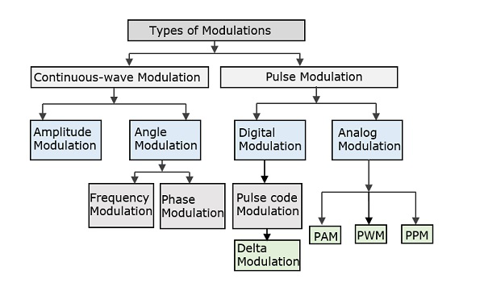

**Task 01:**

1. Set the sampling frequency to 1kHz and carrier frequency to 200 Hz. Generate a time vector having a duration of 0.2 s.

fs = 1000; % Sampling Frequency

fc = 200; % Carrier Frequency

t = (0:1/fs:0.2)';

1. Create two tone sinusoidal signal with frequencies 30 and 60 Hz

x = sin(2*pi*30*t)+2*sin(2*pi*60*t);

1. Generate a Carrier Signal yc = sin(2*pi*fc*t);
2. Plot the modulating Signal and Carrier Signal figure;

**Source Code:**

clc

clear all

close all

fs=1000; %sampling frequency

t=0:0.001:0.2;

fc=200; %carrier frequency

m=sin(2*pi*30*t)+sin(2*pi*40*t); %modulating signal

c=cos(2*pi*fc*t); %carrier Signal

plot(t,m,'r',t,c,'b');

xlabel('Time-Axis');

ylabel('Amplitude-Axis');

title('Modulating Signal,Carrier Signal');

legend('Modulating Signal','Carrier Signal');

**Output:**

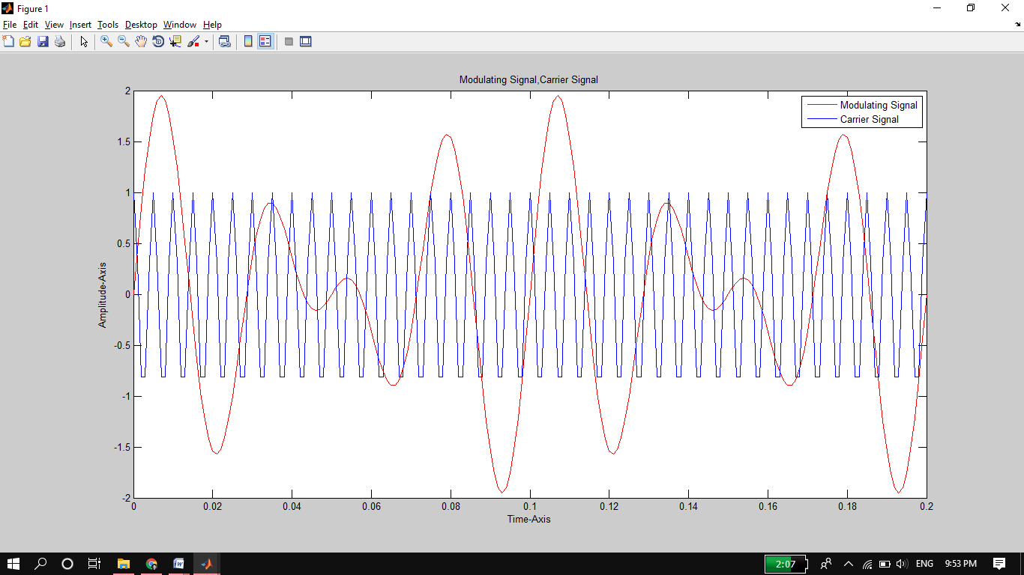

**Task 02:**

1. **Observe Figure 1 and comment on the frequencies of both signals and why.**

As modulating signal is the combination of two different frequencies and carrier signal consist of single higher frequency that’s why their shapes are different.

**Task 03:**

1. Set the frequency deviation to 50 Hz.

fDev = 50;

1. Frequency modulate x (Modulating Signal) using fmmod.

y = fmmod(x,fc,fs,fDev);

1. Plot the original and modulated signals.

plot(t,x,'c',t,y,'b--')

**Source Code:**

figure

fDev = 50; %frequency Deviation in carrier and sampling frequency

y = fmmod(m, fc, fs, fDev);

%fmmod uses the message signal X to modulate the

%carrier frequency Fc (Hz) and sample frequency Fs (Hz),

%where Fs>2*Fc for recovering original carrier signal at reciver.

%FDEV (Hz) is the amount of frequency deviation of the modulated signal.

plot(t,m,'r',t,y,'b'); %y=Modulated Carrier Signal.

xlabel('Time-Axis');

ylabel('Amplitude-Axis');

title('Modulating Signal,Modulated Signal');

legend('Modulating Signal','Modulated Signal');

**Output:**

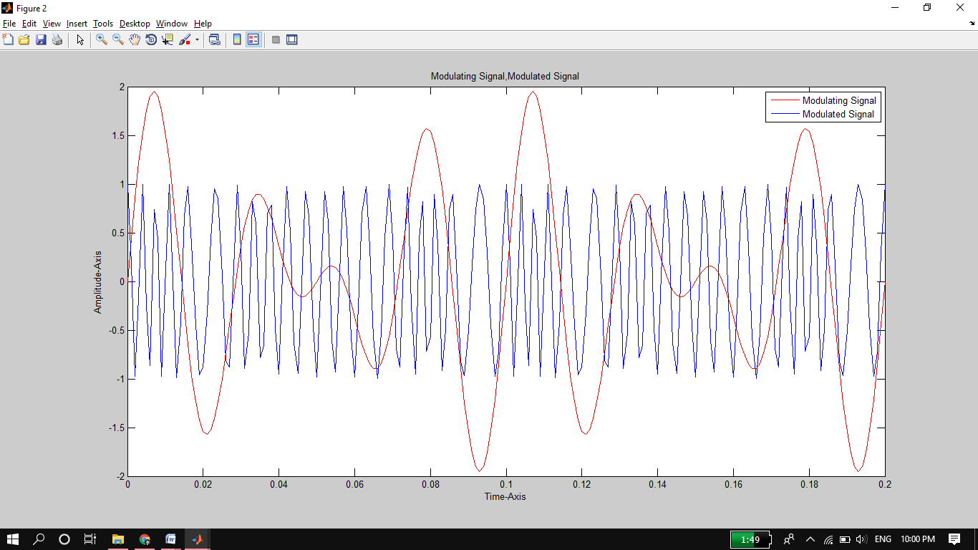

**Task 04:**

1. **Compare and Contrast Figure 1 and Figure 2.**

As carrier signal is modulated using fmmod by frequency deviation 50. That’s why its graph little bit changed.

**Task 05:**

1. **Change FDev to 100 Hz. Obtain the output and plot it (let say Figure 3). Compare and Contrast the output shown in Figure 2 and Figure 3**

Source Code:

figure

fDev = 100; %frequency Deviation in carrier and sampling frequency

y = fmmod(m, fc, fs, fDev);

plot(t,m,'r',t,y,'b'); %y=Modulated Carrier Signal.

xlabel('Time-Axis');

ylabel('Amplitude-Axis');

title('Modulating Signal,Modulated Signal');

legend('Modulating Signal','Modulated Signal')

**Output:**

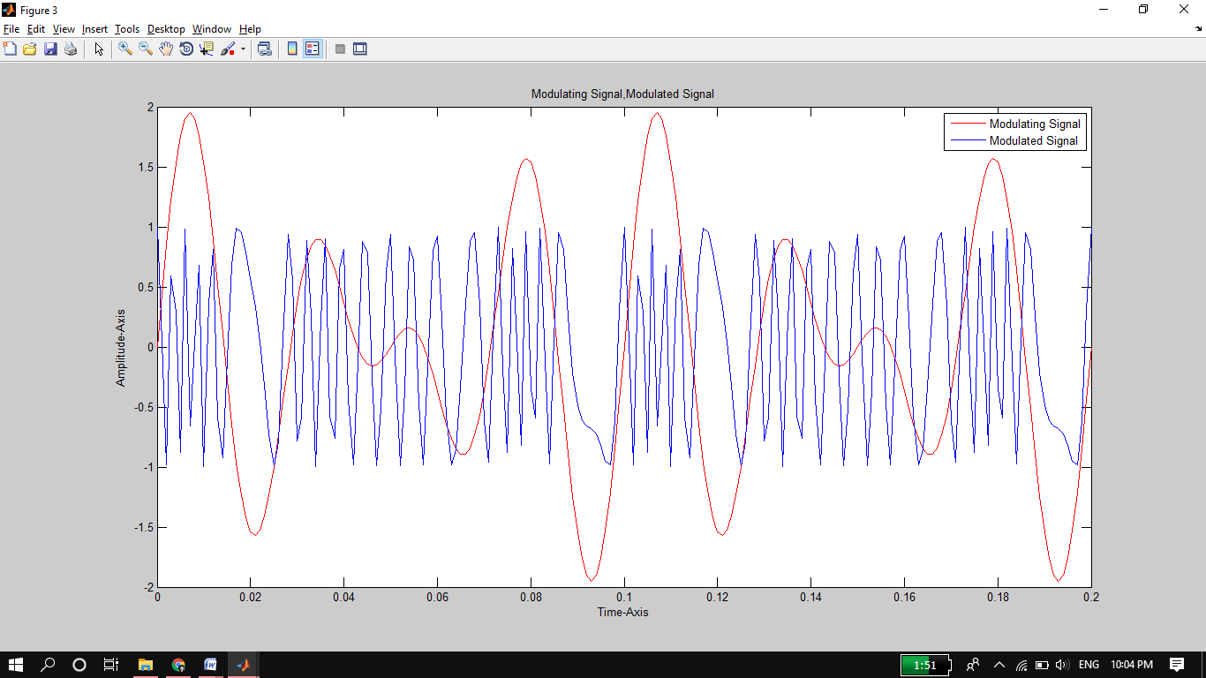

Here plot of Modulated (carrier) signal is contracted more because of increase in amount of frequency deviation from 50 Hz to 100 Hz.

**Task 06:**

1. Perform Frequency Demodulation using Matlab function fmdemod z =
2. Plot the original and demodulated signals

plot(t,x,'c',t,z,'b--');

xlabel('Time (s)')

ylabel('Amplitude')

legend('Original Signal','Demodulated Signal')

**Source Code:**

figure

d=fmdemod(y,fc,fs,fDev); %y=Modulated Carrier Signal.

%demodulates the FM modulated signal y at

%the carrier frequency Fc (Hz). Y and Fc have sample frequency Fs (Hz).

%FREQDEV is the frequency deviation (Hz) of the modulated signal.

plot(t,m,'r',t,d,'b');

xlabel('Time-Axis');

ylabel('Amplitude-Axis');

title('message signal,Demodulated Signal');

legend('message signal','Demodulated Signal')

**Output:**

